Conference Board Leading Economic Index
Increased in February
By Doug Short
March 20, 2014

The Latest Conference Board Leading Economic Index (LEI) for February was released this morning. The index rose 0.5 percent to 99.5 percent from the January's 99.3, an upward revision from 92.2 (2004 = 100). The latest number was above the 0.2 percent forecast by Investing.com.
Here is an overview from the LEI technical notes:
The Conference Board LEI for the U.S. increased for the second consecutive month in February. Large positive contributions from the yield spread and building permits more than offset the negative contributions from weekly hours worked in manufacturing and consumer expectations for business conditions. In the six-month period ending February 2014, the leading economic index increased 2.7 percent (about a 5.4 percent annual rate), faster than the growth of 2.0 percent (about a 4.0 percent annual rate) during the previous six months. In addition, the strengths among the leading indicators have been more widespread than weaknesses in recent months. [Full notes in PDF
Here is a chart of the LEI series with documented recessions as identified by the NBER.
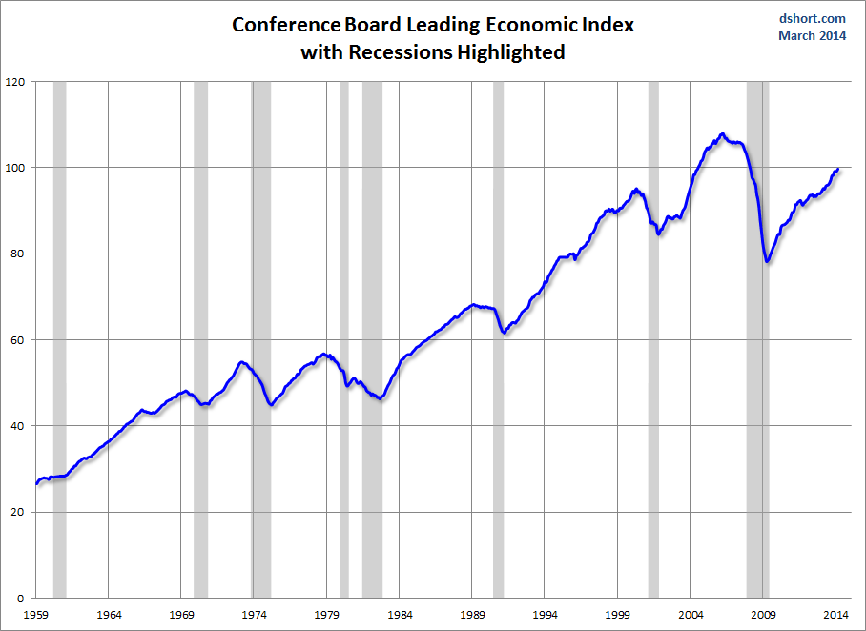
Click for a larger image
And here is a closer look at this indicator since 2000. We can more readily see that the recovery from the 2000 trough weakened in 2012 but began trending higher in the latter part of the year.
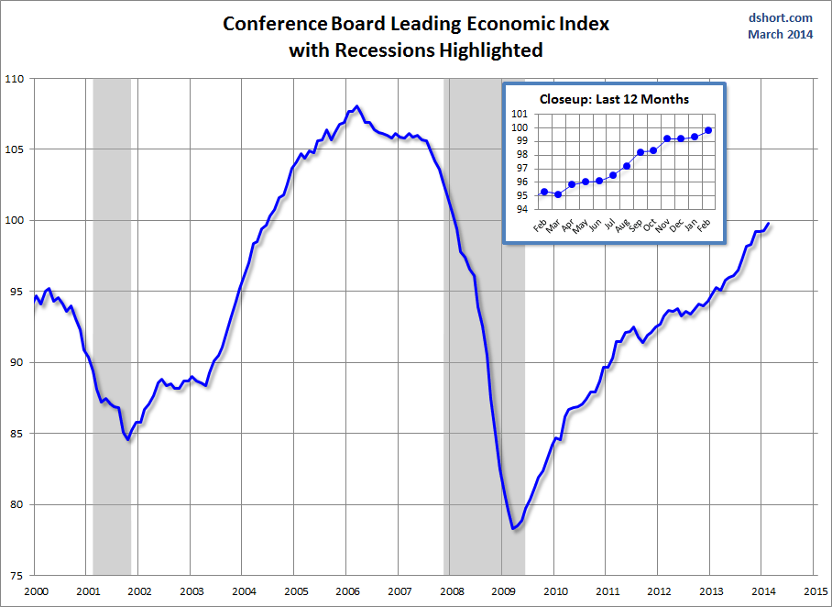
Click for a larger image
For a more details on the latest data, here is an excerpt from the press release:
"The U.S. LEI increased sharply in February, suggesting that any weather-related volatility will be short lived and the economy should continue to improve into the second half of the year," said Ataman Ozyildirim, Economist at The Conference Board. "The strengths and weaknesses in the LEI were balanced in February, with large increases in housing permits and the interest rate spread more than offsetting decreases in the workweek in manufacturing, consumer expectations and rising initial claims for unemployment insurance."
"While the CEI shows the pace of economic activity remained slow at the start of 2014, the trend in the LEI remains quite positive," said Ken Goldstein, Economist at The Conference Board. "The biggest challenge continues to be weak consumer demand, pinned down by weak wage growth. These conditions were still in evidence the first two months of the year, but will likely improve as spring arrives."
For a better understanding of the relationship between the LEI and recessions, the next chart shows the percentage off the previous peak for the index and the number of months between the previous peak and official recessions.
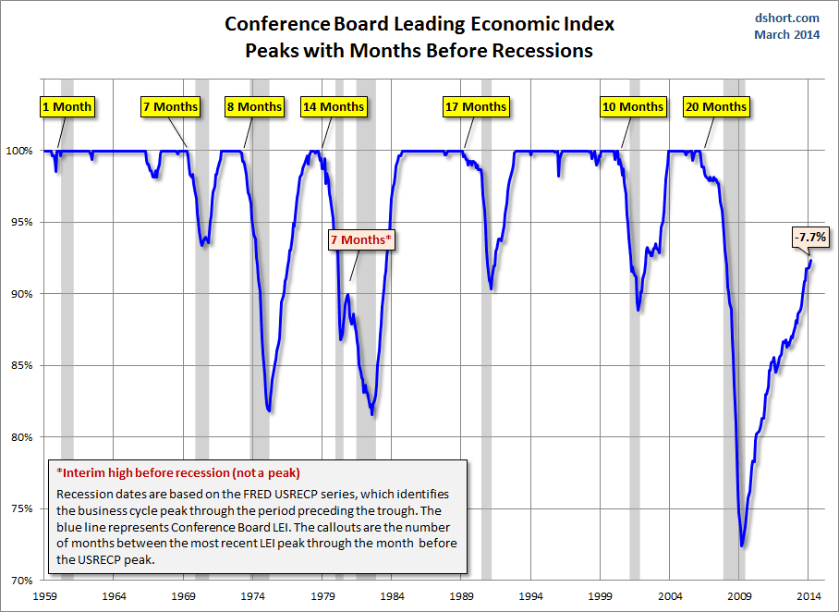
Click for a larger image
Here is a look at the rate of change, which gives a closer look at behavior of the index in relation to recessions.
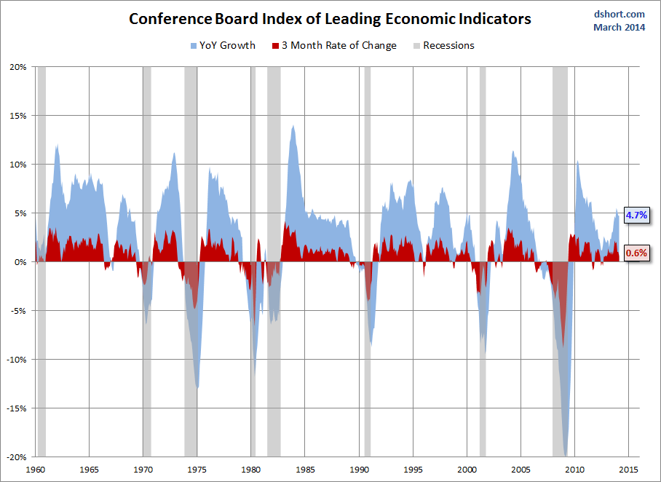
Click for a larger image
And finally, here is the same snapshot, zoomed in to the data since 2000.
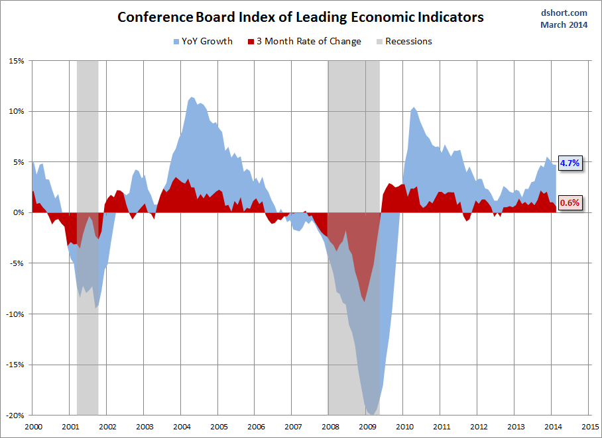
Click for a larger image
Check back next month for an updated analysis.

http://advisorperspectives.com/dshort/updates/Conference-Board-Leading-Economic-Index.php

