Real Median Household Incomes:
Excruciatingly Slow and Erratic Improvement
By Doug Short
December 6, 2013 (Monthly Update)

Overview: The Sentier Research monthly median household income data series is now available for October. Nominal median household incomes were down $230 month-over-month but up $704 year-over-year. However, adjusted for inflation, real incomes increased only $199 MoM and are up only $217 YoY (-0.4% and 0.4%, respectively). And these numbers do not factor in the expiration of the 2% FICA tax cut. The median real household income is up only 2.7% since its Financial Crisis trough set in the summer of 2011, now 26 months later. Improvement has been excruciatingly slow and erratic.

The traditional source of household income data is the Census Bureau, which publishes annual household income data in mid-September for the previous year. The 2012 annual updates were published last week.
Sentier Research, an organization that focuses on income and demographics, offers a more up-to-date glimpse of household incomes by accessing the Census Bureau data and publishing monthly updates. Sentier Research has now released its most recent update, data through October (available here). The data in their report differs from the Census Bureau's data in three key respects:
- It is a monthly rather than annual series, which gives a more granular view of trends.
- Their numbers are more current. The Census Bureau's 2012 data will remain its latest until September 2014.
- Sentier Research uses the more familiar Consumer Price Index (CPI) for the inflation adjustment. The Census Bureau uses the little-known CPI-U-RS (RS stands for "research series") as the deflator for their annual data. For more on that topic, see this commentary.
The first chart below is an overlay of the nominal values and real monthly values chained in October 2013 dollars. The red line illustrates the history of nominal median household, and the blue line shows the real (inflation-adjusted value). I've added callouts to show specific nominal and real monthly values for January 2000 start date and the peak and post-peak troughs.

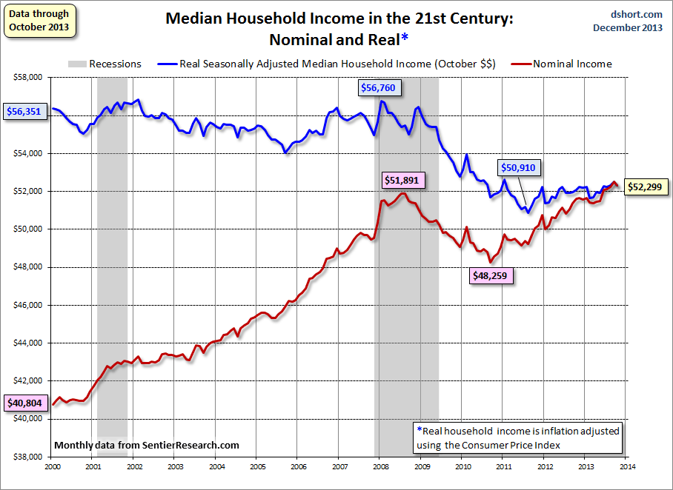
Click for a larger image

In the latest press release, Sentier Research spokesman Gordon Green summarizes the recent data.
Since August 2011, the low-point in our household income series, we have seen some improvement in the level of real median annual household income. While the trend in household income since August 2011 has been uneven, on balance we have seen an upward movement of 2.7 percent since August 2011. We still have a significant amount of ground to make up to get back to where we were before, but at least we have shown some improvement since the low point.
As for the data itself, Sentier makes it available in Excel format for a small fee (here). I have used the latest data to create a pair of charts illustrating the nominal and real income trends during the 21st century.
The blue line in the chart above paints the grim "real" picture. Since we've chained in October 2013 dollars and the overall timeframe has been inflationary, the earlier monthly values are adjusted upward accordingly. In addition to the obvious difference in earlier real values, we can also see that real incomes peaked before the nominal (January of 2008, one month after the recession began, versus July 2008). Also the real post-recession decline bottomed later than the nominal (August 2011 versus September 2010).
The next chart is my preferred way to show the nominal and real household income -- the percent change over time. Essentially I have taken the monthly series for both the nominal and real household incomes and divided them by their respective values at the beginning of 2000. The advantage to this approach is that it clearly quantifies the changes in both series and avoids a common distraction of using dollar amounts ("How does my household stack up?").

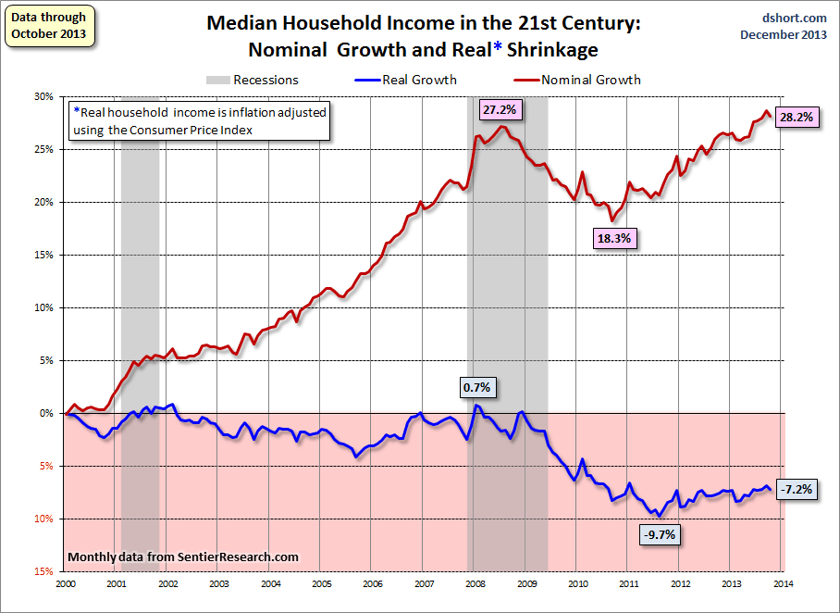
Click for a larger image

The stunning reality illustrated here is that the real median household income series spent most of the first nine years of the 21st century struggling slightly below its purchasing power at the turn of the century. Real incomes (the blue line) hit an interim peak at a fractional 0.7% in early 2008, far below the nominal illusionary peak (as in money illusion) of 27.2% six months later and now at 28.2%, just fractionally off its new high of 28.7% set in September. In contrast, the real recovery from the trough has been depressingly slight.
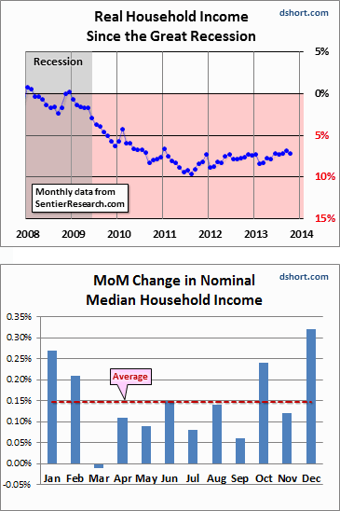
Let's take a closer look at the monthly data since the end of the Great Recession. The adjacent chart highlights the real monthly median values since 2008. The right axis shows the same scale as the chart above -- the percent change from the real household income value at the start of the 21st century. The October 2013 real median annual income is 7.2% below our turn-of-the-century starting point and 7.9% below is 21st century high in January 2008. But the 2013 household experience is worse than these numbers suggest. The Sentier calculations are based on pre-tax data. The expiration of the 2% FICA tax has put an additional hit on disposable household incomes.
Is there seasonality to the monthly data? The column chart shows the monthly averages of nominal month-over-month change since 2000. December is the top performer with January a close second. March has a negative average since the turn of the century. However, the month-over-month volatility of the Consumer Price Index reduces the reliability of the nominal pattern as a clue for what to expect in the in the months ahead.
In Summary...
As the excellent data from Sentier Research makes clear, the mainstream U.S. household was struggling before the Great Recession. At this point, real household incomes are in worse shape than they were four years ago when the recession ended.
I'll close this update with another look at real growth, highlighting the actual monthly data points and adding a three-month moving average. The MA trend has been slowly zigzagging higher since the trough in 2011, and the latest month has risen above a virtual ceiling during the past two years.

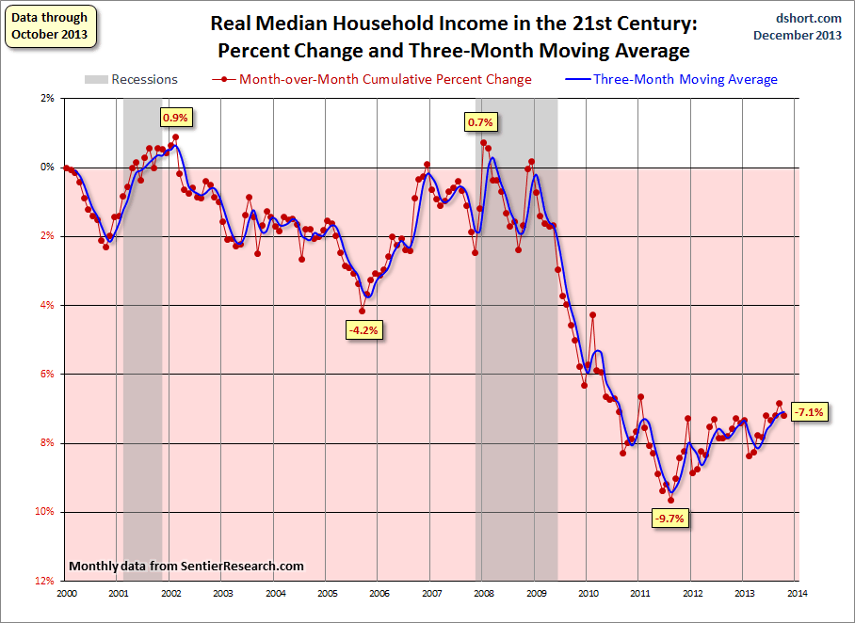
Click for a larger image

Check back next month for the latest update.

Additional Reading:
- Median Household Incomes: The Real Truth about the U.S. Economic Recovery, Four Years Later
- Median Household Incomes after the Great Recession: Household Types and Educational Attainment
- U.S. Household Incomes: A 45-Year Perspective
- U.S. Median Household Incomes by Age Bracket
- Median Household Income Growth: Deflating the American Dream
Also, be sure to download Sentier Research's latest report (PDF), which includes an overlay of real household income and the monthly unemployment rate. Highly recommended!

Note: For more information on the Census Bureau's Current Population Survey (CPS), visit the CPSFrequently Asked Questions page. A question I've often been asked over the years is what qualifies as income in CPS household survey. The CPS definitions page lists the following:
- Earnings
- Unemployment compensation
- Workers' compensation
- Social security
- Supplemental security income
- Public assistance
- Veterans' payments
- Survivor benefits
- Disability benefits
- Pension or retirement income
- Interest
- Dividends
- Rents, royalties, and estates and trusts
- Educational assistance
- Alimony
- Child support
- Financial assistance from outside of the household
- Other income

http://advisorperspectives.com/dshort/updates/Median-Household-Income-Update.php

