Treasury Snapshot: Yields Off Interim Highs
But 30-Year Fixed Mortgage Moves Higher
By Doug Short
July 12, 2013

What's New: I've updated the charts below through Thursday's close (July 11th). The yield on the 10-year note closed yesterday at 2.60%, 10 bps off its previous close and 13 bps off its interim high on July 5th.
The latest Freddie Mac Weekly Primary Mortgage Market Survey, published yesterday, puts the 30-year fixed at 4.51%, a new interim high and the highest average rate since early August of 2011.

Here is a snapshot of the 10-year yield and the 30-year fixed mortgage since 2008.
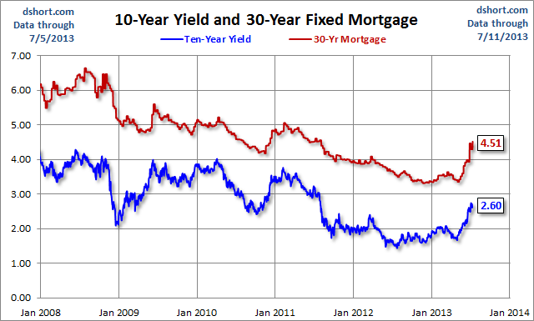
A log-scale snapshot of the 10-year yield offers a more accurate view of the relative change over time. Here is a long look since 1965, starting well before the 1973 Oil Embargo that triggered the era of "stagflation" (economic stagnation with inflation). I've drawn a trendline connecting the interim highs following those stagflationary years. The red line starts with the 1987 closing high on the Friday before the notorious Black Monday market crash. The S&P 500 fell 5.16% that Friday and 20.47% on Black Monday.
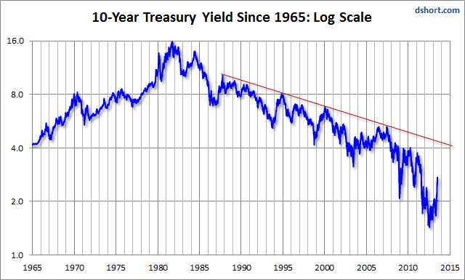
Here is a long look back, courtesy of a FRED graph, of the Freddie Mac weekly survey on the 30-year fixed mortgage, which began in May of 1976.
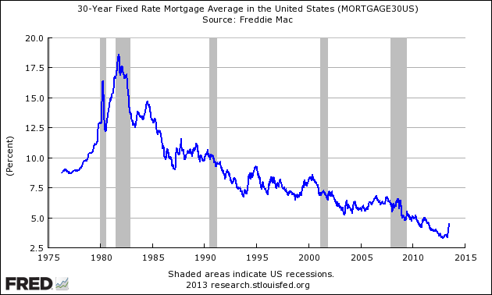
A Perspective on Yields Since 2007
The first chart shows the daily performance of several Treasuries and the Fed Funds Rate (FFR) since 2007. The source for the yields is the Daily Treasury Yield Curve Rates from the US Department of the Treasury and the New York Fed's website for the FFR.

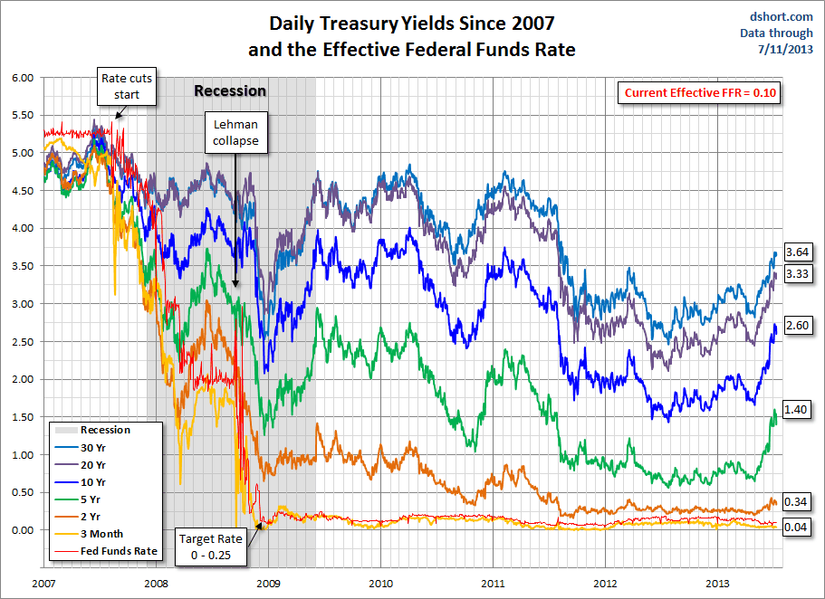
Click for a larger image

Now let's see the 10-year against the S&P 500 with some notes on Federal Reserve intervention. Fed policy has been a major influence on market behavior. It will be interesting to see how the index fares in as Q2 earnings season opens and the market potentially reassesses its dependency on Fed easing that might be nearing an inflection point.

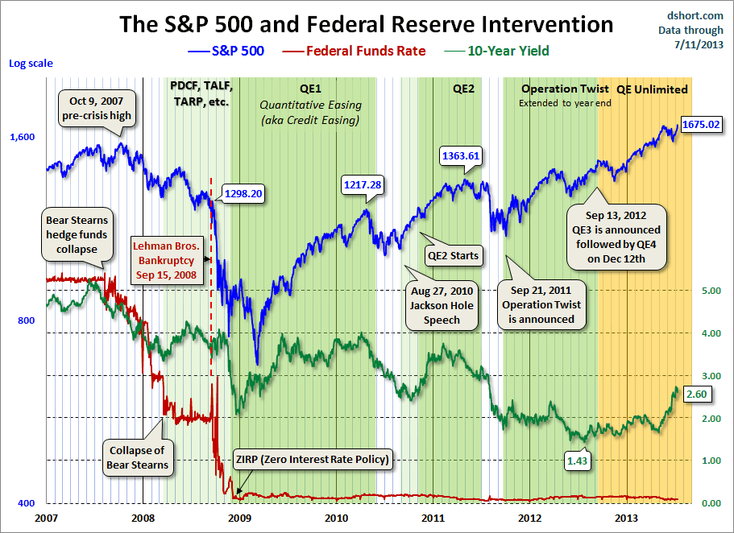
Click for a larger image

For a long-term view of weekly Treasury yields, also focusing on the 10-year, see my Treasury Yields in Perspective, which I update on weekends.

http://advisorperspectives.com/dshort/updates/Treasury-Yield-Snapshot.php

